CSE211 Web Programming, Fall Semester

Assignment 1: Websites Conceptual Design and mock-up

221101354, omar Khaled Masoud

**2.3.1. Part 1: research**

**1. Defining Characteristics of Web 2.0 to Web 4.0**  
  
Web 2.0 replaced the static websites with an interactive, colorful web. It is all about user participation. Think of websites such as Facebook, Twitter, and YouTube—these aren't just websites; they are communities wherein each person gets a chance to have his say heard. People started creating content, shared experiences, and connected like never before.  
  
As we entered into Web 3.0, the plot really thickened. This phase, often termed the Semantic Web, develops meaning out of the huge data amounts online. It is not just about sharing; rather, it's all about understanding. With technologies in the knack of artificial intelligence and machine learning, the web started learning through our interactions to tailor experiences towards meeting our needs.  
  
Now, move on to Web 4.0, everything interconnected. Envision wise devices communicating with one another in a seamless way to learn what you do for life to become easier. Web 4.0-that is, the intuitive web that is smart and more or less human-sits in wait.  
  
**2. Mandatory Features and Enabling Web 2.0:**  
  
Web 2.0 was the collaborative Web or the user-generated content-based Web. Following are the features which introduced this generation:  
  
Social Networking: Finds applications in sites like Facebook and Twitter, where people can connect with others and also share slices of their lives in real time.  
User-Generated Content: Sites like YouTube and Wikipedia populated the Internet, showing how ordinary users can add to a growing body of knowledge and creative work.  
Interactivity: the possibility of comments and shares, relating to the content created, facilitated very lively online forums.  
This was revolutionary about networking: one could now share thought ideas and creations with the entire world; thus, democratizing the web through the use of these technologies, enabling diverse voices across different geographies.  
  
Semantic Understanding: It is about making machines understand contexts and relations between diverse pieces of information and, in effect, making the web much smarter. In other words, any information would be safer, more transparent, giving users full control over their personal information. This is realized by technologies like blockchain. Personalization: AI algorithms analyze our preferences and behaviors with a view to delivering customized content and experiences.  
With these developments, the web started becoming relevant and helped us surf for relevant information in a far easier and quicker way to enhance our experiences online.  
  
**4. Key Features and Empowerment of Web 4.0**  
  
As we may expect, the reported features of Web 4.0 are going to bring a completely new dimension in the way we will interact with technology. For instance:  
  
Intelligent Automation: AI would perform most tasks which today take a little more human input, thus simplifying many tasks in order to make life easier.  
IoT Integration: Our devices will be connected by default. Technology will be literally working for us in an integrated fashion, efficiently and smoothly.  
Improved User Experience: Interfaces will be increasingly intuitive and permit natural interaction with technology, through voice or gestures.  
What Web 4.0 does is seek to build an ecosystem wherein technologies will understand us, support us, and present us with solutions to improve our daily lives.

**5. Importance of Collective Intelligence and Social Technologies**  
  
Constituent parts of the digital life are collective intelligence, social networking, media, and social bookmarking. Sharing ideas and collaboration that come along with building up communities of like-minded are the stuff of all those technologies. All these kinds of technologies provide empowerment opportunities for both individuals and the organizations themselves. They unblock creativity and innovation with regard to power that lies through the user knowledge around the entire globe.  
  
**6. Impacts on Business Plans**  
  
It reflects the adoption and evolution of the web technologies that have very strong implications for today's and future businesses. Companies can utilize social media to market their products, gather consumer data to make better decisions, or employ AI for their operations. Knowing and connecting with one's customers will hold the key for brand loyalty and service delivery.  
  
**7. Personal Professional Use of Latest Technologies**  
  
I will embrace new web technologies in my career to make my work very efficient and helpful to customers. For instance, it would allow me to make more insightful analytics of customers by using AI on data analysis, which will help in the personalization of services. It will also allow me to connect various data with the principles of Web 3.0 in order to come up with informed decisions over projects.

**2.3.2. part 2: Website planning**

**1. Define the Purpose of the Website:**  
Thewebsite that is to be designed shall sell furniture items. In other words, it should be able to facilitate an online catalog where a variety of furniture items pertaining to different categories are provided, thus enabling customers to surf through and read thorough items and place orders directly on the website.

**2. What Would You Like the Website to Accomplish?**  
Theprimary objective isto offer the best furniture to clients, coupled with a great online purchasing experience. It includes ease of navigation, secure online payment, as well as customer service. The website should also be able to create brand trust and keep customers interested through well-informative content presented in an appealing way.

**3. Who is Your Intended Audience?**  
The target audience is adults aged 25-55 years, targeting people who are eager to buy furniture for their houses or offices, which include home owners, renters, and interior designers looking

**4. What Opportunities, Problems, or Issues Does the Website Address?**  
The website, as many of its customers have noted, helps address the challenge of limited physical furniture showrooms with a virtual showroom reaching a much greater number of potential customers. The website further enhances this with detailed information on products, customer reviews, and images that could support customer buying decisions from any location.

**5. What Kind of Content Could Be Incorporated on Your Website?**  
Content will include high-quality images, detailed product descriptions, customer reviews, blog articles on home decor tips, video demonstrations, and a customer support section. User-generated content, such as reviews and testimonials, will enhance engagement and trust.

**6. How Will the Site Serve the Client?**  
The site will provide clients with easy access to furniture options, information on the latest trends, and special offers. Clients can shop anytime, from any location, with support available through chat and contact forms. Additionally, they’ll be able to track orders and get recommendations based on previous purchases.

**7. What’s the Best Method for the User to Do What’s Wanted?**  
A streamlined, interactive navigation system will be used to help users easily find products. Categories, filters (e.g., price, style, color), and a search function will make locating specific items straightforward. Clear, visible call-to-action buttons for adding items to the cart and checkout will guide users efficiently.

**8. How Will Users Find the Function?**  
The website will be designed with intuitive icons and labeled buttons to ensure users can quickly locate essential functions such as "Add to Cart," "Checkout," and "Customer Support." Pop-up guidance and tooltips will assist first-time visitors as needed.

**9. How Will the Results of the Function Be Received?**  
When users complete a purchase, they will receive confirmation pop up and a follow-up email containing their order details, delivery time, and tracking information

**10. What Will the Receiver Do with the Received Entries?**  
The customer service team will handle received entries (e.g., orders, queries, feedback) by processing orders, responding to inquiries, and addressing feedback. Sales data can also inform future inventory and marketing decisions.

**11. How Will the Receiver Deal with Results?**  
Results will be managed through an order management system that handles inventory updates, shipment tracking, and customer follow-up. Any issues, such as out-of-stock items, will be communicated proactively to maintain customer satisfaction.

**12. What Follow-Up Will Be Needed?**  
Follow-up includes sending automated emails after purchase, requesting customer feedback, and offering post-purchase support. Regular updates on new arrivals or special promotions will also be sent to retain customer engagement.

**13. List of Related or Similar Sites and Why Chosen:**

* *Wayfair.com:* Chosen for its extensive product range and interactive, user-friendly interface. The layout offers a good example of using filters and product categories effectively.
* *Ikea.com:* Known for its streamlined checkout process and effective use of images and 3D product previews, which enhance the online shopping experience.

**14. Planning Analysis Sheet:**

**a. Website Goal:**  
To create an accessible, visually engaging, and reliable e-commerce platform for purchasing quality furniture online.

**b. Working Titles of Pages (Excluding Home Page):**

* Shop
* Product details
* Cart
* Check out
* Contact Us

**c. Description of Each Page’s Contents:**

* **Home:** Featured products, current sales, top categories, and a search bar.
* **shop:** Product listings, filters, and sorting options.
* **Product Details:** Images, descriptions, specifications, reviews, and an "Add to Cart" button.
* **Contact Us:** Form for inquiries, along with location and contact details.

**d. Forms Usage:**  
Forms will be used for customer registration, newsletter subscriptions, contact submissions, and surveys for product reviews and feedback.

e.

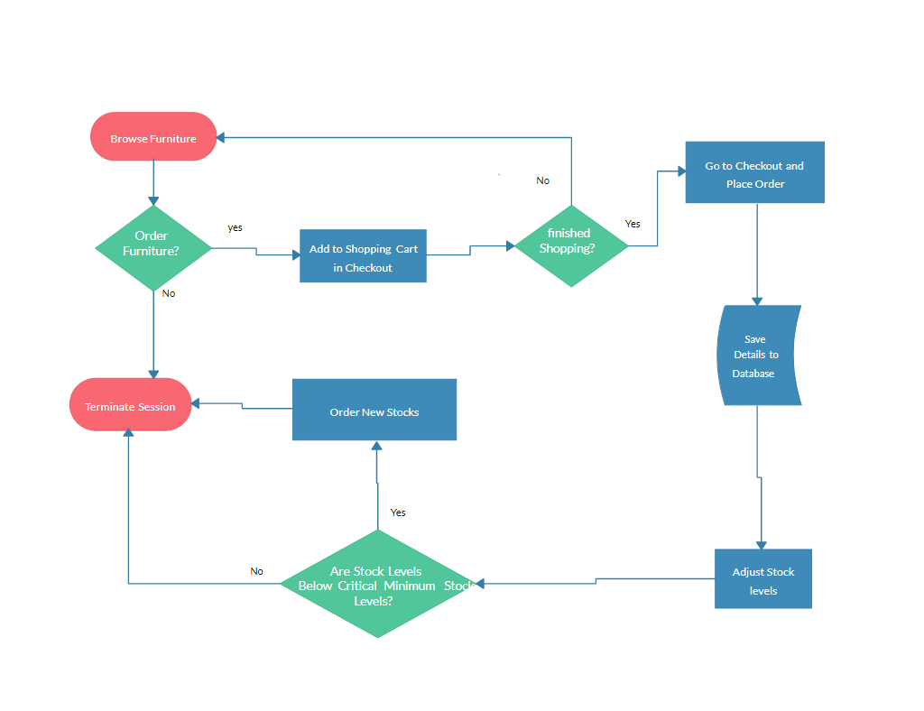

f.

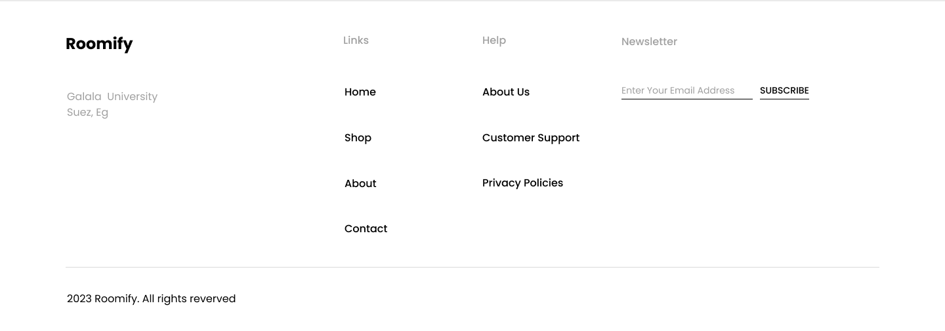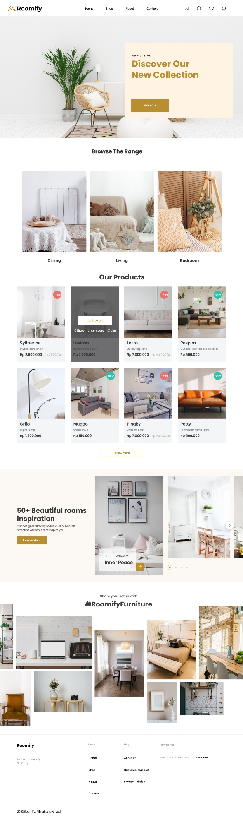

**2.3.3. part 2: Website design**

**[A]**

1. **Law of PRAGNANZ (Good Figure, Law of Simplicity)**

Simple means that the website will employ a clean minimalist layout, with clearly defined categories of products as well as uncomplicated navigation. There will be minimalistic icons and brief descriptions, and plenty of whitespace to let users focus on the most critical content without unnecessary distractions.

1. **Closure (Link Individual Elements to Form a Pattern)**

Product images and their descriptions will be displayed on grids; hence, even if the boundaries are not marked, it will imply a full structure. Featured collections, for instance, will appear as groups so that this will cue the users to perceive these products as part of something bigger.

1. **Symmetry and Order (Effectively Communicate Information Quickly)**

Product displays will be done using symmetry, with page layouts balanced in columns and rows to easily present users with comparable items side by side. This quickens the pace with which users absorb information, thus complementing a more intuitive way of shopping.

1. **Figure/Ground (Relationship Between Positive Elements and Negative Space)**

Figure-ground contrast will be utilized in the design, where products take the figure and the background colors constitute the ground. This will provide maximum contrast for clear visual separation. Negative space around every product photograph will focus the user's attention directly on the furniture pieces.

1. **Uniform Connectedness: Relationship Between the Elements**

Elements included are things like price tags, "Add to Cart" buttons, and star ratings; each of these elements will have a consistent and regular placement across the different product pages, hinting at their related functionalities. In this manner, it would constitute a smoother, more predictable flow of shopping.

1. **Common Region (Connection Between Elements)**

Each product will be laid out in a bounded box, distinguished from others. This will in turn allow users to visually group related products, such as similar styles or collections, and maintain organization while shopping.

1. **Proximity (Utilizing Empty Space to Create Relationships)**

Related information, for example, product information, variants, and reviews, will be placed in close proximity indicating its relationship. The proximity of related products on category pages will allow users to compare several items without clutter.

1. **Continuation (Continuous Perception of Shapes)**

The navigation bar and footer will span horizontally to create flow between pages. There will be smooth transitions between categories because the layouts are similar.

1. **Common Fate (Synchrony) (Items Moving or Changing Together Perceived as Related)**

Sliders featuring collections or sales will also animate items together, thereby relating them to one another. Image and "Add to Cart" hover effects will also change color in concert, reinforcing their function.

1. **Parallelism (Parallel Elements Are Seen as More Related)**

Items of the same product category will be placed into parallel rows or columns. The parallel, through relatedness will allow the user to visually relate items that are in categories such as "Living Room" or "Bedroom" furniture.

1. **Similarity (Elements with Similar Characteristics Are More Related)**

Similar style products, for example, modern or rustic will use similar fonts, similar color, and similar layouts so that the users can more easily identify items similar in style or category.

1. **Past Experience (Observer's Past Experience)**

Recognizable icons, such as a shopping cart for purchases or a magnifying glass for search, are to be used to align with users' past experiences on other e-commerce sites. Familiar navigation patterns and interactions reduce learning curves, making the website useable by new visitors.

**All the design templates at the end of the report**

**[b]**

**1-**

* 320px — 480px: Mobile devices.
* 481px — 768px: iPads, Tablets.
* 769px — 1024px: Small screens, laptops.
* 1025px — 1200px: Desktops, large screens.
* 1201px and more — Extra-large screens, TV.

**2-**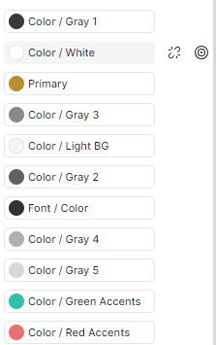

**3-** we will maintain a contrast ratio of at least 4.5:1 for normal text and 3:1 for large text, per Web Content Accessibility Guidelines (WCAG). Tools like the WebAIM contrast checker will verify that color choices meet these standards

**4-**

* Html
* CSS (tailwind)
* JavaScript (react.js)

**5-**

WordPress will be considered due to their flexibility and user-friendly interfaces. These CMS options will allow easy content updates, blog management, and product information updates, enabling non-technical staff to maintain the site effectively.

**6-**

* Nodejs
* MongoDB
* ExpressJS

**7-**

* Page Load Speed**:** Using tools like Google PageSpeed Insights to minimize load times.
* Bounce Rate: Analyzing this to understand user retention and page engagement.
* Conversion Rate: Tracking sales conversions from website visits.
* Average Session Duration: Observing how long users stay on the site.
* User Flow: Identifying common paths taken by users, to optimize navigation.

8-

<!DOCTYPE html>

<html lang="en">

<head>

    <meta charset="UTF-8">

    <meta name="viewport" content="width=device-width, initial-scale=1.0">

    <title>Roomify - Furniture Store</title>

    <link rel="stylesheet" href="styles.css">

    <!-- Include Bootstrap or Tailwind CSS for layout -->

</head>

<body>

    <!-- Header -->

    <header>

        <div class="navbar">

            <a href="#" class="logo">Roomify</a>

            <nav>

                <ul>

                    <li><a href="#">Home</a></li>

                    <li><a href="#">Shop</a></li>

                    <li><a href="#">About</a></li>

                    <li><a href="#">Contact</a></li>

                </ul>

            </nav>

            <div class="header-icons">

                <a href="#"><i class="user-icon"></i></a>

                <a href="#"><i class="cart-icon"></i></a>

                <a href="#"><i class="search-icon"></i></a>

            </div>

        </div>

    </header>

    <!-- Main Banner -->

    <section class="banner">

        <div class="banner-content">

            <h2>New Arrival</h2>

            <h1>Discover Our New Collection</h1>

            <a href="#" class="btn">Buy Now</a>

        </div>

    </section>

    <!-- Browse The Range -->

    <section class="browse-range">

        <h2>Browse The Range</h2>

        <div class="categories">

            <div class="category">Dining</div>

            <div class="category">Living</div>

            <div class="category">Bedroom</div>

        </div>

    </section>

    <!-- Our Products -->

    <section class="our-products">

        <h2>Our Products</h2>

        <div class="products-grid">

            <div class="product">

                <img src="product1.jpg" alt="Syltherine">

                <h3>Syltherine</h3>

                <p>Stylish cafe chair</p>

                <span class="price">Rp 2.500.000</span>

                <span class="old-price">Rp 3.500.000</span>

                <button>Add to cart</button>

            </div>

            <!-- Repeat for other products -->

        </div>

        <button class="show-more">Show More</button>

    </section>

    <!-- Beautiful Rooms Inspiration -->

    <section class="room-inspiration">

        <div class="inspiration-text">

            <h2>50+ Beautiful rooms inspiration</h2>

            <p>Our designer already made a lot of beautiful prototypes of rooms that inspire you.</p>

            <a href="#" class="btn">Explore More</a>

        </div>

        <div class="inspiration-gallery">

            <!-- Image Gallery -->

            <div class="gallery-item"><img src="inspiration1.jpg" alt="Room Inspiration"></div>

            <!-- Repeat for more images -->

        </div>

    </section>

    <!-- Social Media Section -->

    <section class="social-media">

        <h2>Share your setup with #RoomifyFurniture</h2>

        <div class="social-gallery">

            <!-- Social Images -->

            <div class="social-item"><img src="social1.jpg" alt="Social Media"></div>

            <!-- Repeat for more images -->

        </div>

    </section>

    <!-- Footer -->

    <footer>

        <div class="footer-content">

            <div class="footer-section">

                <h4>Links</h4>

                <ul>

                    <li><a href="#">Home</a></li>

                    <li><a href="#">Shop</a></li>

                    <li><a href="#">About</a></li>

                    <li><a href="#">Contact</a></li>

                </ul>

            </div>

            <div class="footer-section">

                <h4>Help</h4>

                <ul>

                    <li><a href="#">About Us</a></li>

                    <li><a href="#">Customer Support</a></li>

                    <li><a href="#">Privacy Policies</a></li>

                </ul>

            </div>

            <div class="footer-section">

                <h4>Newsletter</h4>

                <form>

                    <input type="email" placeholder="Enter Your Email Address">

                    <button type="submit">Subscribe</button>

                </form>

            </div>

        </div>

        <p>&copy; 2024 Roomify, All rights reserved</p>

    </footer>

</body>

</html>

The website design on figma  
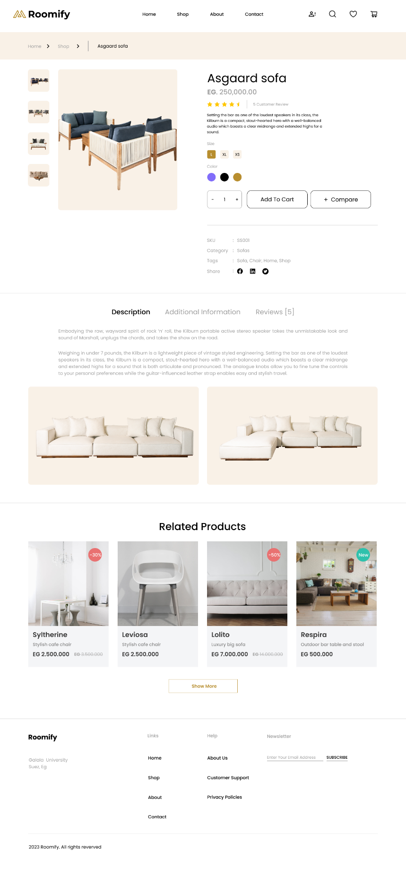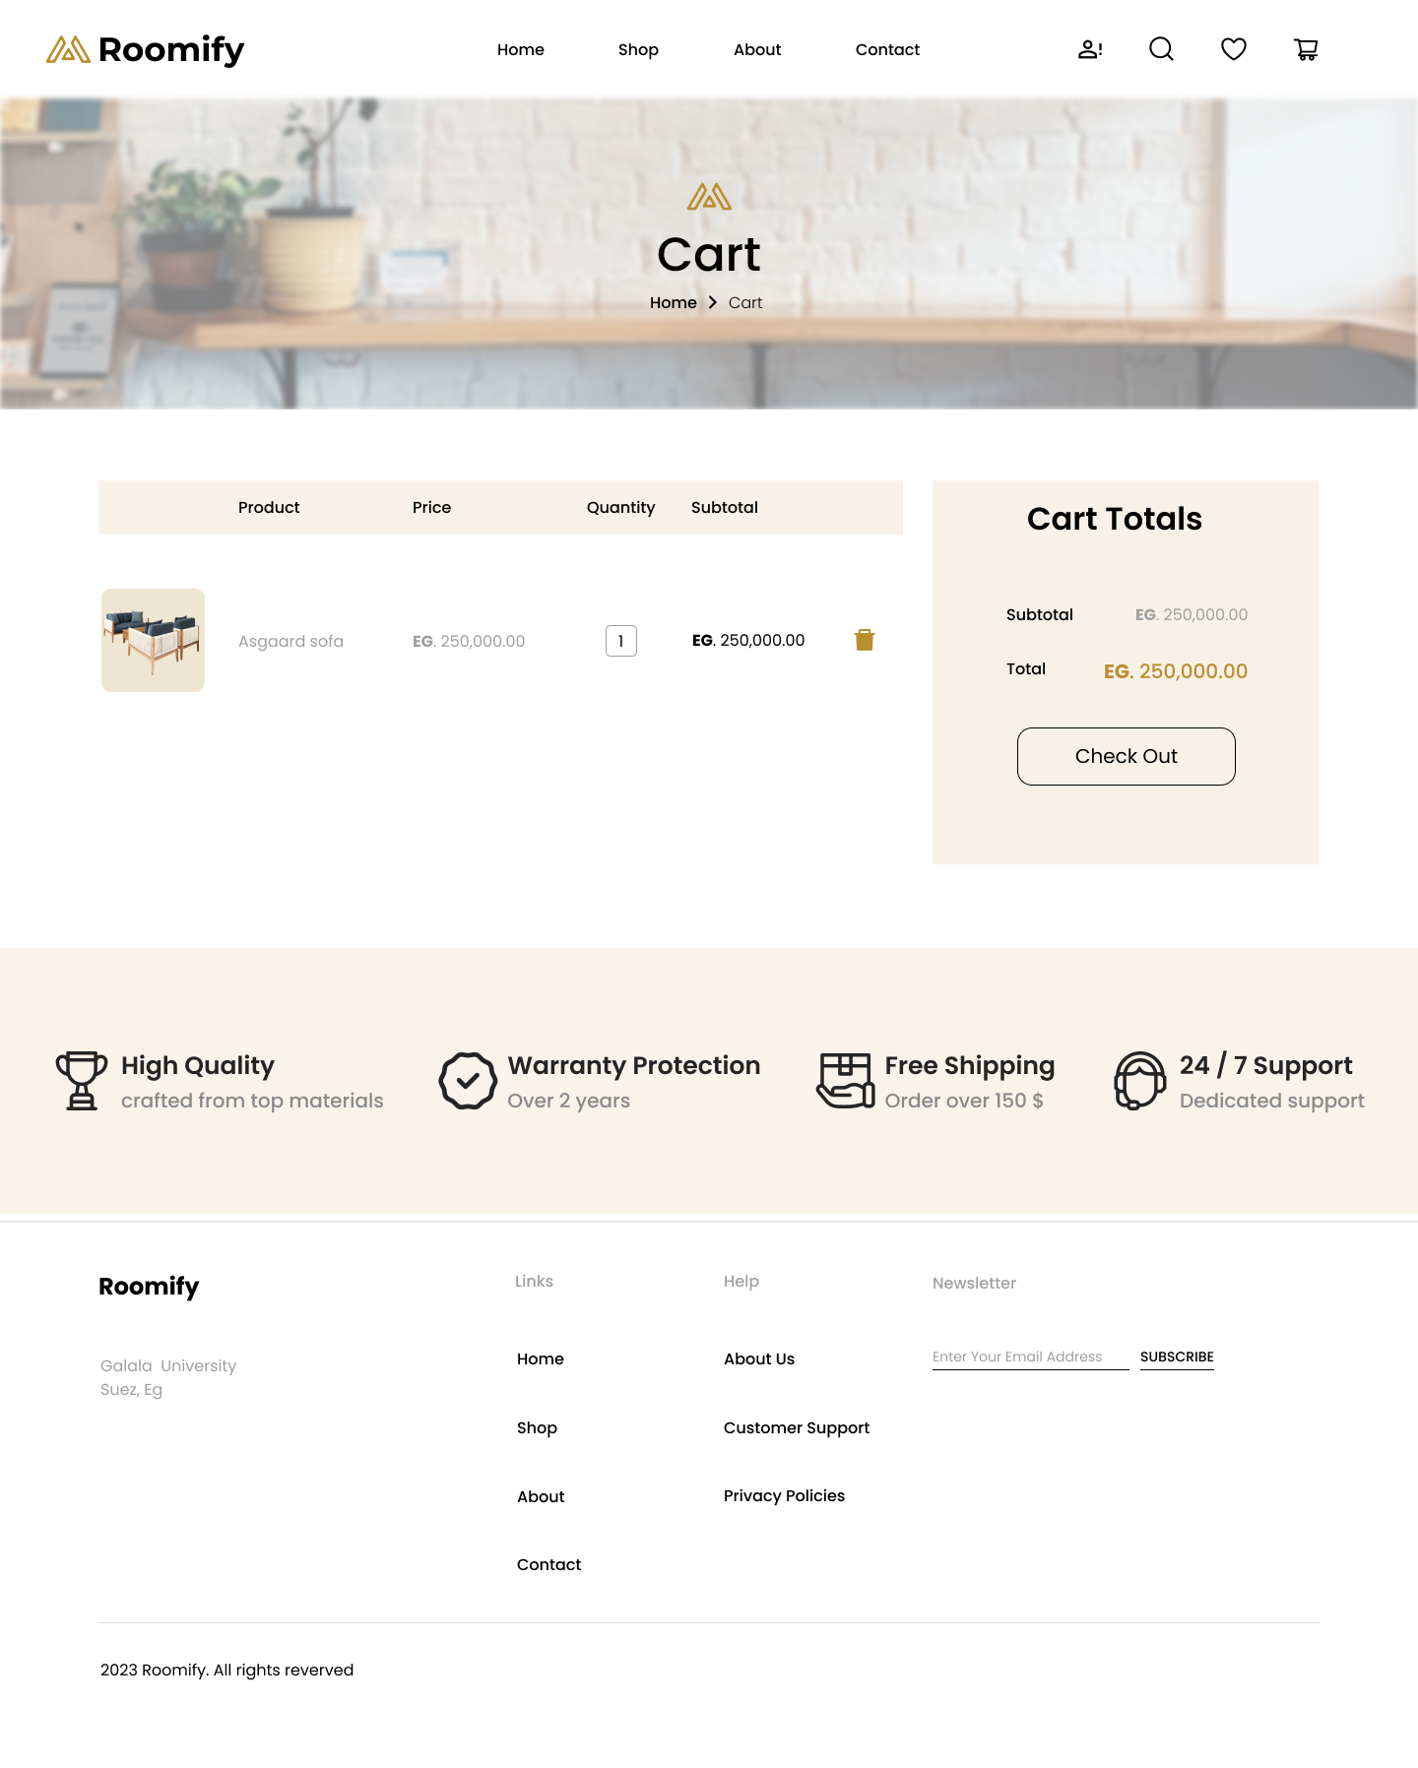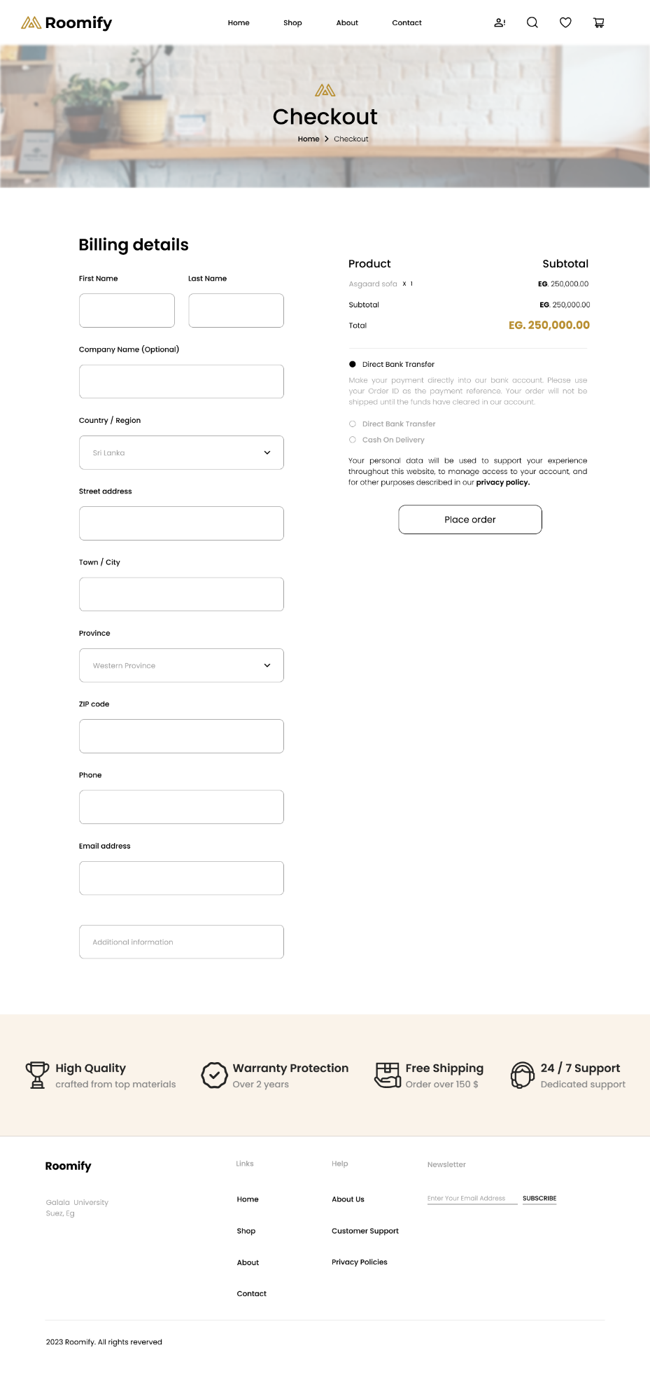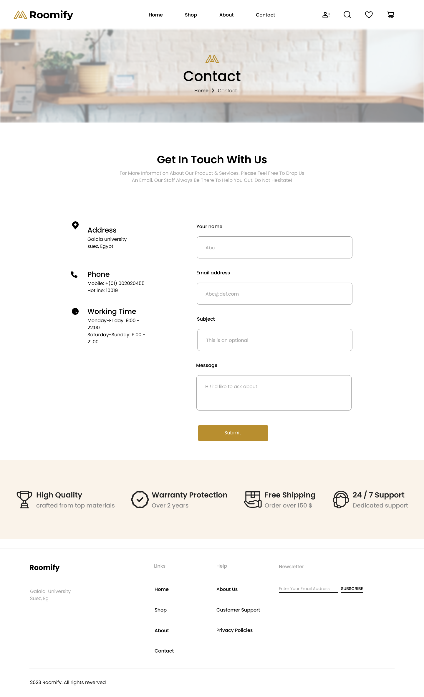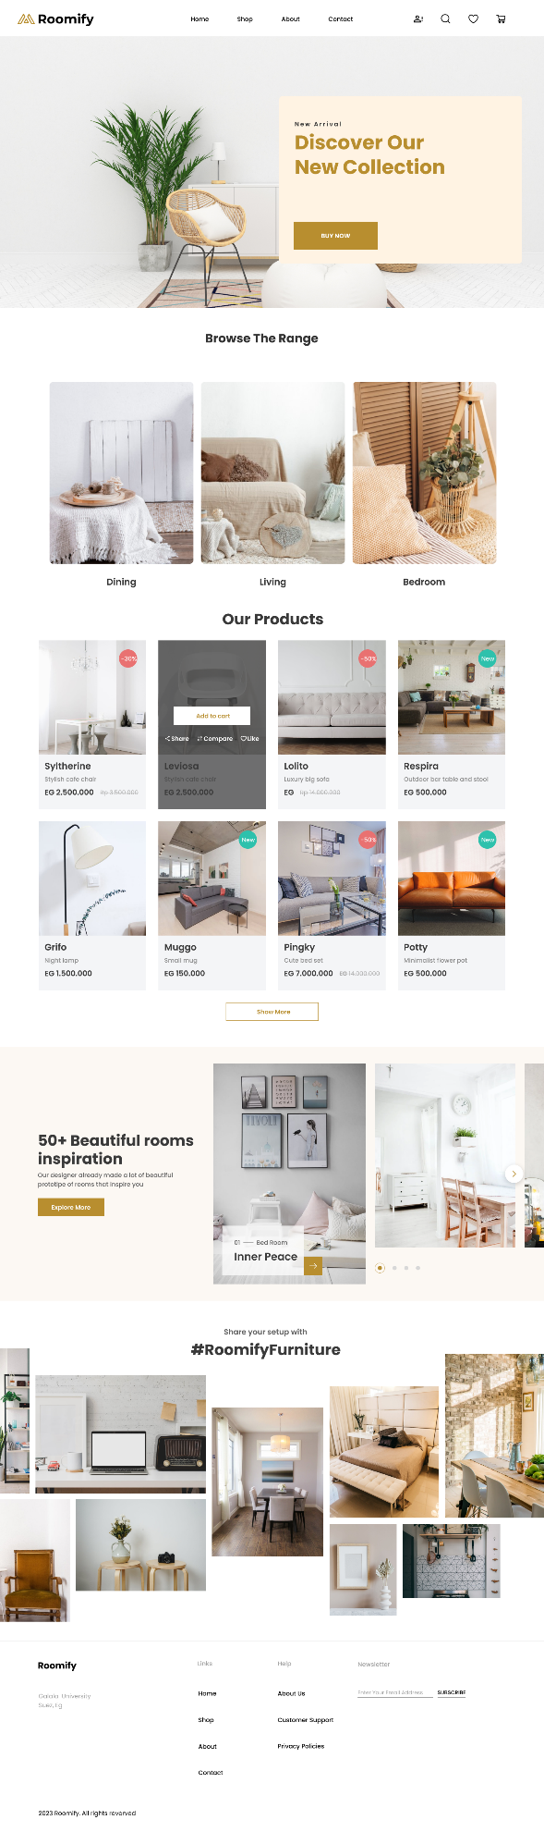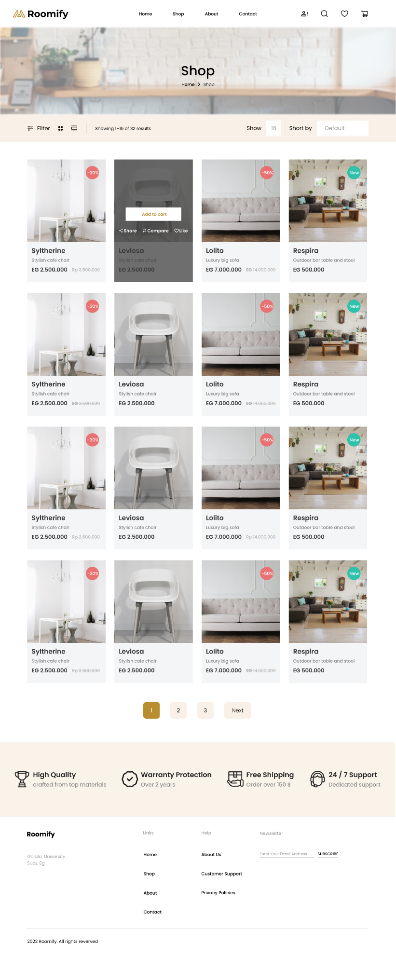

**References:**

* WebAIM. (n.d.). *Contrast Checker*. Retrieved from https://webaim.org/resources/contrastchecker/
* Google PageSpeed Insights. (n.d.). Retrieved from https://developers.google.com/speed/pagespeed/insights/
* Krug, S. (2014). *Don't Make Me Think, Revisited: A Common-Sense Approach to Web Usability*. New Riders.
* Beaird, J., & George, J. (2014). *The Principles of Beautiful Web Design*. SitePoint.
* Ware, C. (2012). *Information Visualization: Perception for Design, 3rd Edition*. Morgan Kaufmann.
* Berners-Lee, T., & Fischetti, M. (2001). *Weaving the Web: The Original Design and Ultimate Destiny of the World Wide Web*. Harper.
* Alexander, B. (2006). *Web 2.0: A New Wave of Innovation for Teaching and Learning?* EDUCAUSE Review, 41(2), 32–44. Retrieved from https://www.educause.edu/ir/library/pdf/erm0621.pdf
* Cripps, K. (2017). *What is Web 4.0 and Why Does it Matter?* Gartner Research. Retrieved from https://www.gartner.com/en/insights/internet-of-things
* Surowiecki, J. (2004). *The Wisdom of Crowds*. Anchor Books.
* Chaffey, D., & Ellis-Chadwick, F. (2019). *Digital Marketing: Strategy, Implementation, and Practice*. Pearson.
* Kaplan, A. (2020). *Artificial Intelligence, Machine Learning, and Evolving Web Technologies for Business and Society*. Business Horizons.
* Nielsen, J. (2000). *Designing Web Usability: The Practice of Simplicity*. New Riders.
* Mulder, S., & Yaar, Z. (2006). *The User is Always Right: A Practical Guide to Creating and Using Personas for the Web*. New Riders.
* Halvorson, K., & Rach, M. (2012). *Content Strategy for the Web*. New Riders.
* Garrett, J. J. (2010). *The Elements of User Experience: User-Centered Design for the Web and Beyond*. New Riders.
* Laudon, K., & Traver, C. (2020). *E-Commerce 2020: Business, Technology, and Society*. Pearson.
* Newman, D. (2018). *Building an E-Commerce Website*. Retrieved from https://www.nngroup.com/articles/ecommerce/
* Google Developers. (n.d.). *PageSpeed Insights*. Retrieved from https://developers.google.com/speed/pagespeed/insights/
* Jones, S. (2014). *Comparison of E-Commerce Platforms for Furniture Industry*. International Journal of Retail & Distribution Management.